**Lab 8 Name _________________________________________**

**MCSE 1 Sharing Resources between computers**

**Objective:**

In this lab you will:x

- create and share folders on the Ottawa computer

- create groups and assign permissions to the folders

- access the folders on Ottawa from the Hamilton computer

- authenticate between computers employing all 3 methods of authentication

**Procedure:**

_x__ Start Ottawa (Windows 7) and Hamilton (Windows 8). Log into the local Administrator’s account on each computer.

__x_ Make sure you can ping by name between Ottawa and Hamilton. If you are having trouble pinging Hamilton, check the firewall again. When Hamilton joined the domain in the last lab, the firewall may have been turned on.

**Ottawa:**

_x__ Create 3 folders in the root of C: on Ottawa. They will be called **Architecture**, **Engineering**, and **Accounting**.

_x__ Share the 3 folders. To do this right click on a folder and select **Properties**. Make the selections shown in figure 1.

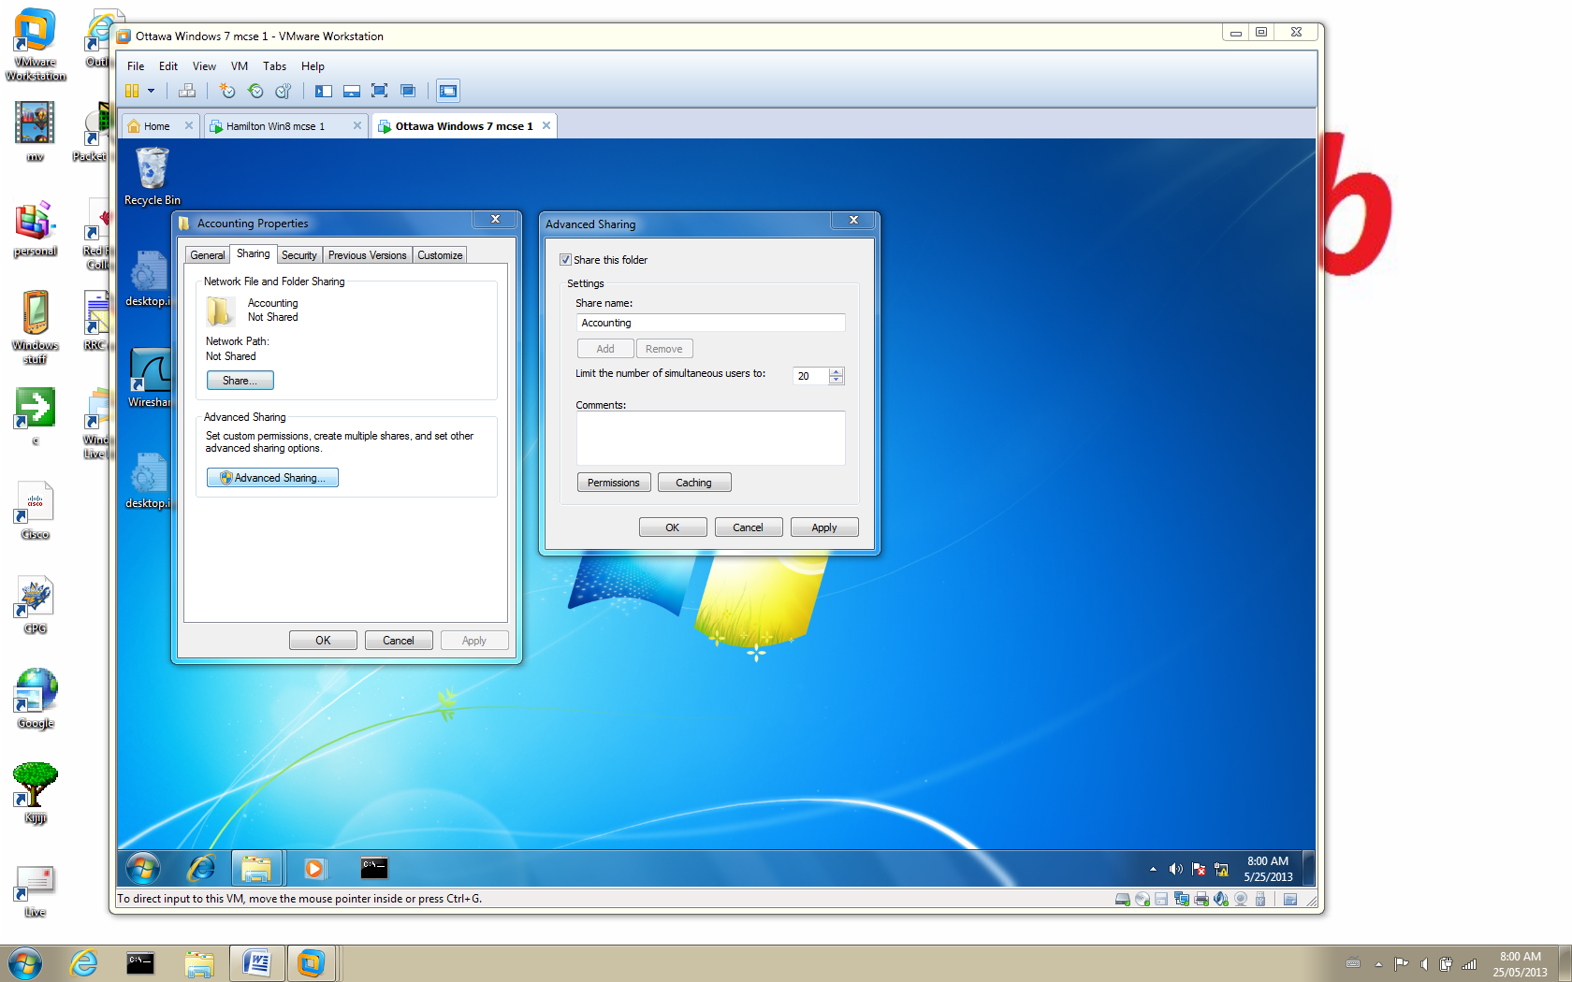

Fig. 1 Sharing folders on a Windows 7 computer

__x_ Create 2 text files in each of the 3 folders. Put a line or two in each file so they will not be empty.

**1. Capture the contents of the Accounting folder in Windows Explorer. Make sure both text files you created are visible in the right-hand pane. Make sure the status bar indicates “shared”**

At this point in the lab, you should have 3 shared folders and each folder should

contain 2 text files.

__x_ Create 6 new accounts on Ottawa. Call them, **Acct1, Acct2, Arch1, Arch2, Eng1, and Eng2**.

__x_ Create 3 new groups on Ottawa. Call them **Accountants**, **Engineers**, and **Architects**.

__x_ Add the new users to their respective new groups; ie. Acct1 and Acct2 should be added to the Accountants group, etc

**2. Capture the membership list of the Engineers group showing that eng1 and eng2 have been added to the group.**

**Local logins**

Figure 2 shows the permissions we want the groups to have for each of the

shared folders when they log in **locally** on the computer.

All permissions except FULL

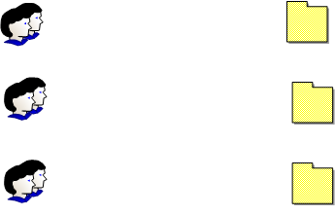

Architecture

Architects

Run

Run

Engineers

Engineering

All permissions except FULL

Accounting

Accountants

All permissions except FULL

Fig. 2 Permissions each group has when they log in locally

Figure 2 says the effective permissions each group has to the folder associated

with their department is “all permission”. This means they can run, copy, delete,

create, change, and rename any files in the folder.

In addition the Architects can run and copy programs and data from the

Engineer’s folder and the Engineers can run and copy programs and data from

the Architects folder.

__x_ Open the **Security** page of each folder and assign the permissions shown in figure 2. This is the NTFS permissions. ie. For the **Architecture** folder, **Architects** need the **modify** permission and **Engineers** need the **Read and Execute** permission.

Notice when you go to add the groups and assign the permissions the existing

permissions are greyed-out indicating the permissions are inherited and can not

be modified.

__x_ On each of the 3 folders break the inheritance by clicking on the **Advanced** button on the **Security** page and follow the screen shots shown in figure 3.

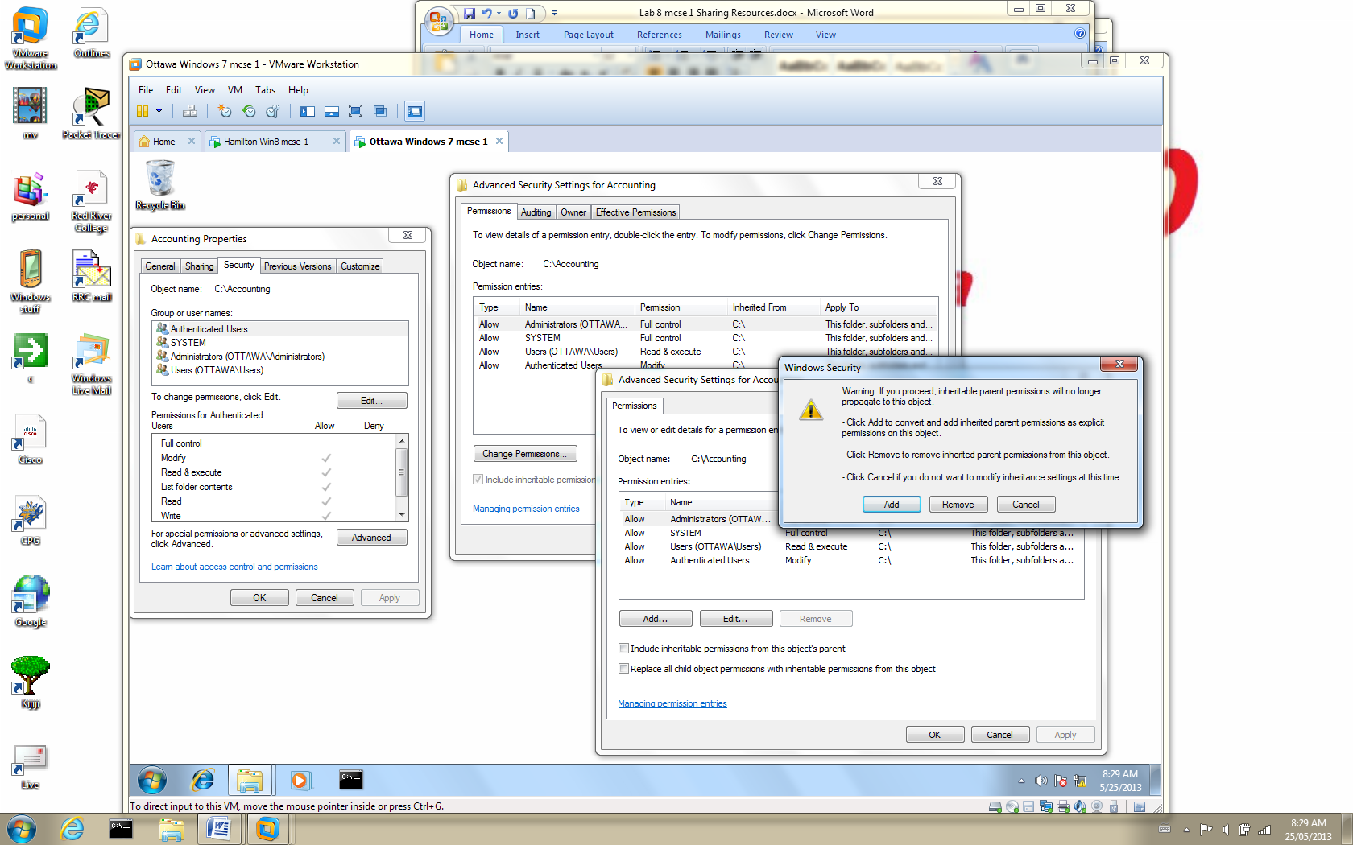

Fig. 3 Follow the screen shots to break the inheritance

__x_ When you are given the choice between **Add** and **Remove**, choose **Add**.

__x_ Remove the **Authenticated Users** and **Users** groups from the DACL. Delete the two groups in this window. Everyone who logs in is a member of these two groups.

_x__ Now you can make the NTFS permission assignments as illustrated in figure 2. Figure 4 shows the steps to follow when adding the Engineers group to the Engineer folder.

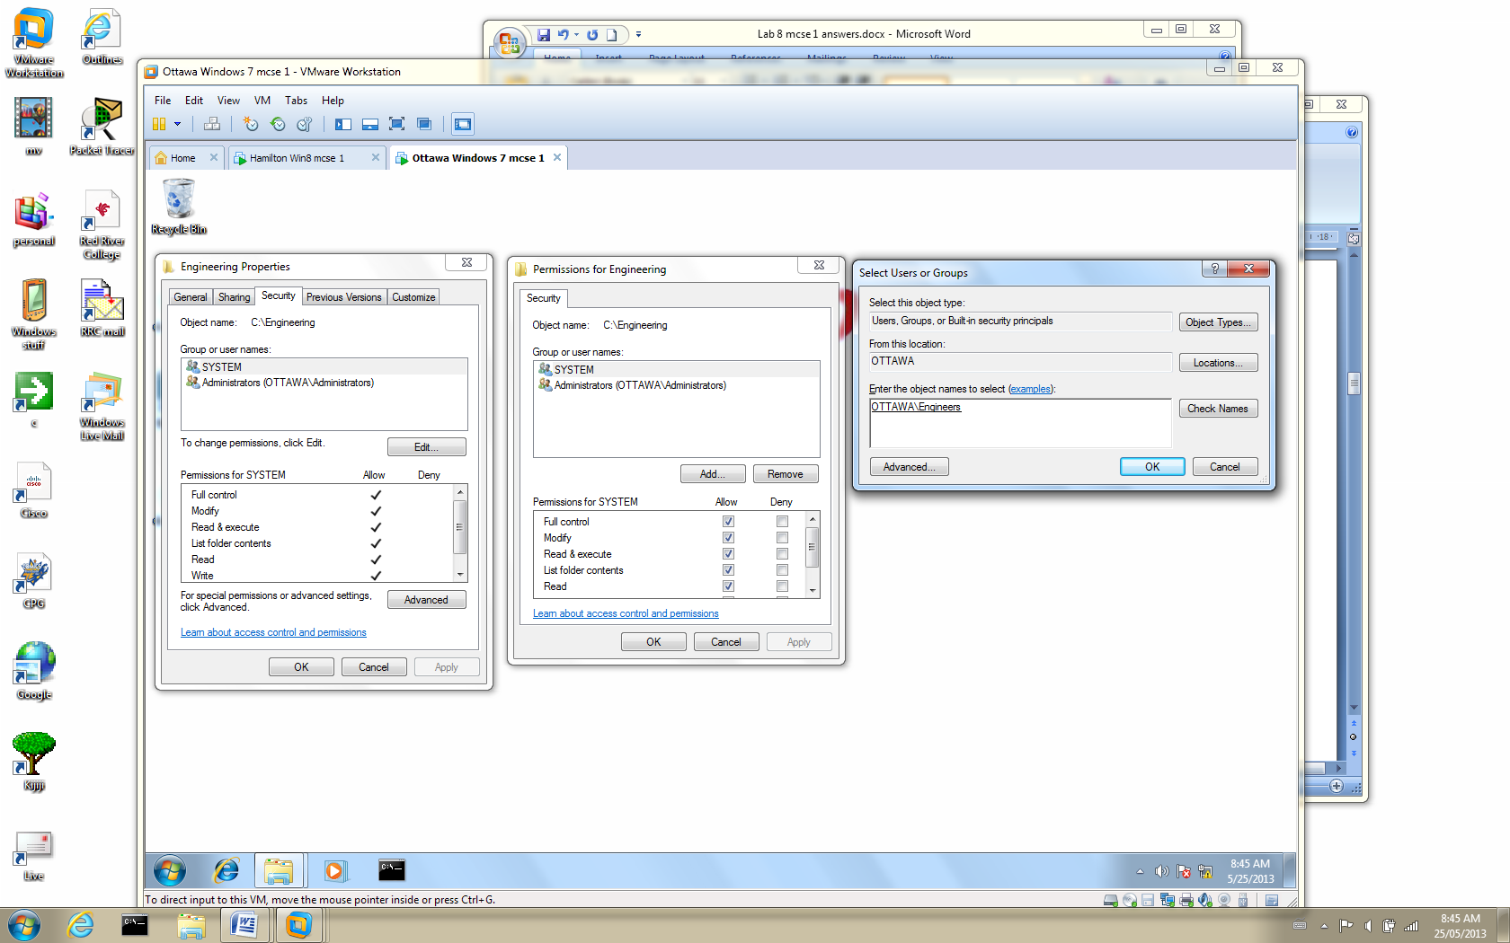

Fig. 4 Adding a group to the NTFS permissions of a folder

**3. Capture the Security page for the Engineering folder showing what permissions you have assigned. Highlight the Engineers group so their permissions are displayed.**

**Remote logins**

**Ottawa:**

_x__ Open the **Share** page on the Architecture folder. Click on **Advanced Sharing** and then click on the **Permissions** button. What you see is the default share permissions when a folder is shared.

**4. Record the default permissions on a shared folder. Record the group and what permission has been granted to them.**

**Hamilton:**

_x__ Log into Hamilton as the Administrator.

_x__ Press the Windows key and the letter “r” key at the same time. In the **Run** box that appears type **\\ottawa**. Be patient, it may take up to 30 seconds before you get a response from Ottawa.

You should now see all the shared folders and printers on Ottawa.

__x_ Double-click on the **Architecture folder**. After a few seconds the two files you created in this folder should be accessible.

__x_ Double-click on one of the files. You should contents of the file.

**5. Capture the desktop on Hamilton showing the Architecture on Ottawa folder with the two files in it. The contents of the file you double-clicked on should also be visible in the screen capture.**

__x_ Close the opened file and try to delete it. You do not have enough permissions to delete it.

_x__ Open a command prompt on Hamilton and type **whoami /groups.** This command will list all the groups the current user that is logged in, belongs to. The display is not easy to read. Let’s try again.

This time type **whoami /groups > c:\group.txt**. This command will create a

file called **group.txt** and place it in the root of C:\. The display in this text file

will be easier to read.

**6. Capture the contents of the group.txt file.**

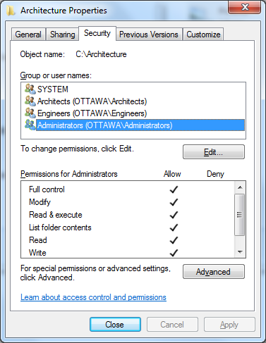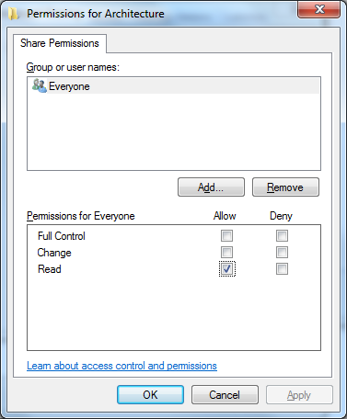

Fig. 5 The administrator has “Read” permissions at the share level and

“Full Control” at the NTFS security level for the Architecture folder on Ottawa

You logged into the Administrator’s account on Hamilton and since he is a

member of the group **Everyone**, he has the **Share** permission of **READ** which is

enough permission to access the **Architecture** folder. He is a member of the

**Administrators** group so he has **FULL Control** at the NTFS level. Since he is

accessing the folder from another computer the Share permission of **READ**

restricts what he can do in the folder. That is why he could not delete the file.

**Ottawa:**

_x__ Open all 3 folders and remove the group **Everyone** from the share permissions.

**Hamilton:**

__x_ On Hamilton, try to access the Architecture folder again.

**7. Capture the Error message that pops up when you try to access the Architecture folder**

Figure 6 shows the permissions we want the groups to when they log into

Hamilton and access the 3 shared folders found on Ottawa.



All Rights except FULL

Architecture

Architects

Run

Run

Engineers

Engineering

All Rights except FULL

All Rights except FULL

Accountants

Accounting

Fig. 6 Permissions each group has when they log in remotely

**Ottawa:**

_x__ Open the **Share** page on each of the 3 folders and give the groups **CHANGE** permission to the folders as indicated in figure 6. This will grant them “All Rights”.

_x__ Give the Architect group **READ** permission to the Engineer folder. This will allow them to run programs and copy files from the Engineering folder.

_x__ Give the Engineer group **READ** permission to the Architecture folder.

**8. Capture the Share page for the Engineering folder showing what permissions you have assigned. Highlight the Engineers group so their permissions are displayed.**

It appears the Administrator on Hamilton did not have to authenticate to Ottawa

to access the folders. The only reason he did not is because the Administrator

on Ottawa has the same password as the Administrator on Hamilton.

When the Administrator on Hamilton tried to access resources on Ottawa,

Ottawa was presented with the credentials (username=Administrator,

password=P@ssw0rd) that the Administrator on Hamilton logged in with. Since

both Administrators have the same credentials, the Hamilton Administrator was

authenticated by Ottawa.

**Hamilton:**

_x__ Create a new user on Hamilton, called **Lab8**.

_x__ On Hamilton, log in as **Lab8**.

_x__ Try to access the Architecture folder on Ottawa. (It may take a full minute or more before you get any response, so be patient).

Notice, this time you are forced to log in. Since there is no matching account on

Ottawa for **Lab8**, he cannot access Ottawa’s resources until he supplies the

credentials of a user on Ottawa.

_x__ Use **Ottawa\eng1** credentials to log in. (It may take another minute before you get a response, again).

_x__ Try accessing all 3 folders.

**9. Which of the 3 folders can Lab8 access? Explain why this is so.**

_x__ Close the Explorer window that was giving you access to the shared folders on Ottawa.

__x_ Try to connect to the shared folders on Ottawa again.

Notice this time you did not have to supply the credentials of Ottawa\Eng1. The

first time you supplied the credentials for Eng1, Ottawa gave the Lab8 user a

session ticket which grants Lab8 access to Ottawa as if he was Eng1. This

session ticket can be used by the Lab8 user as long as he is logged in. When he

logs out, the session ticket is cancelled.

_x__ Log out of Lab8’s account. Log back in as Lab8.

_x__ Try to access the shared folders on Ottawa, again.

After a short while, you will be asked to supply the credentials of a user that

exists on Ottawa. The session ticket that granted Lab8 access to Ottawa as

Eng1, was cancelled when Lab8 logged out.

__x_ Supply the credentials of Ottawa\Eng1, again.

__x_ While Lab8 is using the credentials of **Eng1**, try the following 4 tasks on each of the 3 folders. Answer “yes” for each operation that is successful in each folder. Answer “No” if it was not successful.

|  |  |  |  |
| --- | --- | --- | --- |
| When **Eng1** logs  in from Hamilton | Accounting | Architecture | Engineering |
| **Open a file** |  |  |  |
| **Edit and save a file** |  |  |  |
| **Rename a file** |  |  |  |
| **Delete a file** |  |  |  |

___ Log out and log back in as Lab8. Access the shares on Ottawa by supplying the credentials of **Acct1**. Fill in the table supplied below.

|  |  |  |  |
| --- | --- | --- | --- |
| When **Acct1** logs  in from Hamilton | Accounting | Architecture | Engineering |
| **Open a file** |  |  |  |
| **Edit and save a file** |  |  |  |
| **Rename a file** |  |  |  |
| **Delete a file** |  |  |  |

___ Log out and log back in as Lab8. Access the shares on Ottawa by supplying the credentials of **Arch1**. Fill in the table supplied below.

|  |  |  |  |
| --- | --- | --- | --- |
| When **Arch1** logs  in from Hamilton | Accounting | Architecture | Engineering |
| **Open a file** |  |  |  |
| **Edit and save a file** |  |  |  |
| **Rename a file** |  |  |  |
| **Delete a file** |  |  |  |

**10. Create the table showing the answers you got when Lab8 used the credentials of Eng1.**

**11. Create the table showing the answers you got when Lab8 used the credentials of Acct1.**

**12. Create the table showing the answers you got when Lab8 used the credentials of Arch1.**

There are 3 ways to authenticate to a remote computer:

1. have an account with the identical username and password set up on the

remote computer. (Administrator and P@ssw0rd on both computers).

2. supply a username and password of a user on the remote computer when

challenged to enter a username and password. (Use Ottawa\Eng1 and

P@ssw0rd when challenged).

3. use the “Manage my network passwords” option.

We saw how the first authentication method works when the Administrator on Hamilton did not have to explicitly authenticate to Ottawa because he had the same credentials as the Administrator on Ottawa.

We saw an example of how the second form of authentication works when the Lab8 user was challenged by Ottawa and the Lab8 user provided credentials of various users; acct1, eng1, and arch1.

The third method using “Manage my network passwords” allows a user to store the credentials of users on various hosts. When the user connects to another computer, his computer provides the stored credentials of a user on the remote computer.

Let’s configure Hamilton to manage passwords for the Lab8 user. This 3rd method of configuring username/password credentials of users on other computers can only be performed if the user is a local administrator.

**Hamilton:**

_x__ Log in as the Administrator of Hamilton and add the Lab8 user to the

Administrators group.

_x__ Log out and log back in as Lab8.

_x__ On Hamilton, click on **Control Panel** and click on the green label **Users Accounts**.

_x__ Click on the blue label **Manage your Credentials**. Figure 7 will appear.

_x__ Click on **Add a Windows credential**.

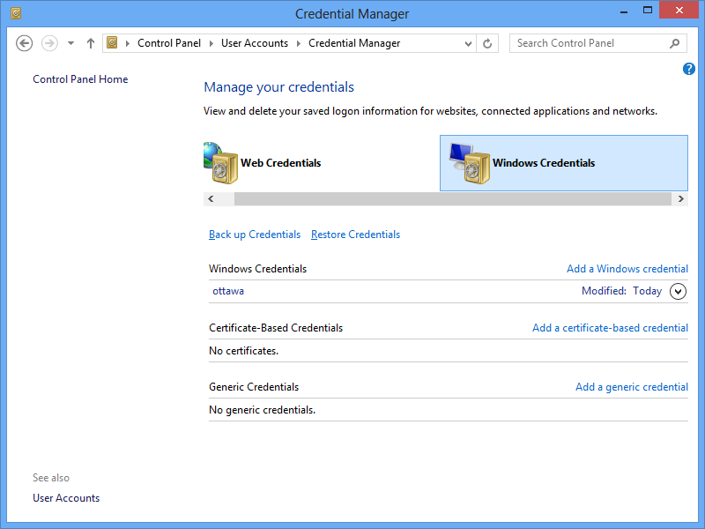

Fig. 7 Managing credentials on Hamilton

__x_ Fill in the fields as shown in figure 8.

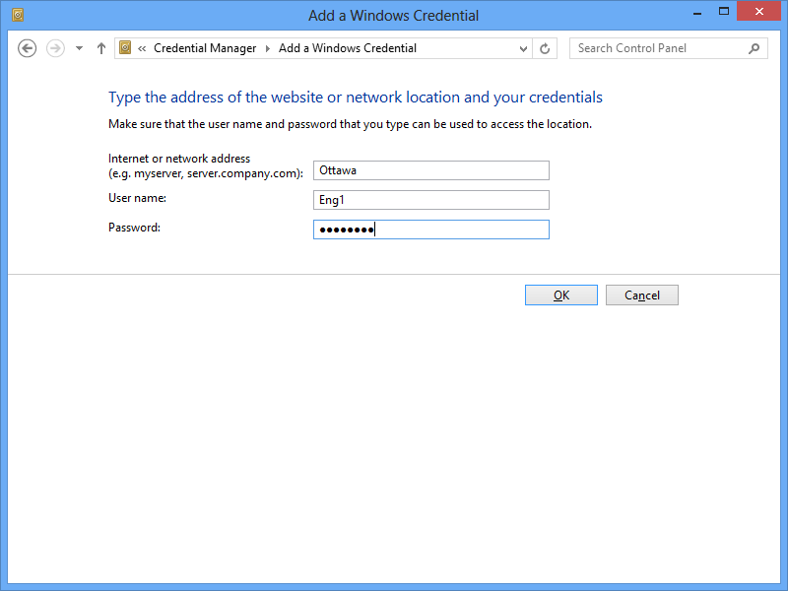

Fig. 8 Supplying the credentials of Eng1

_x__ Try to access Ottawa. You should be successful without having to provide a password.

_x__ Open a DOS window and type whoami. The window should look like figure 9.

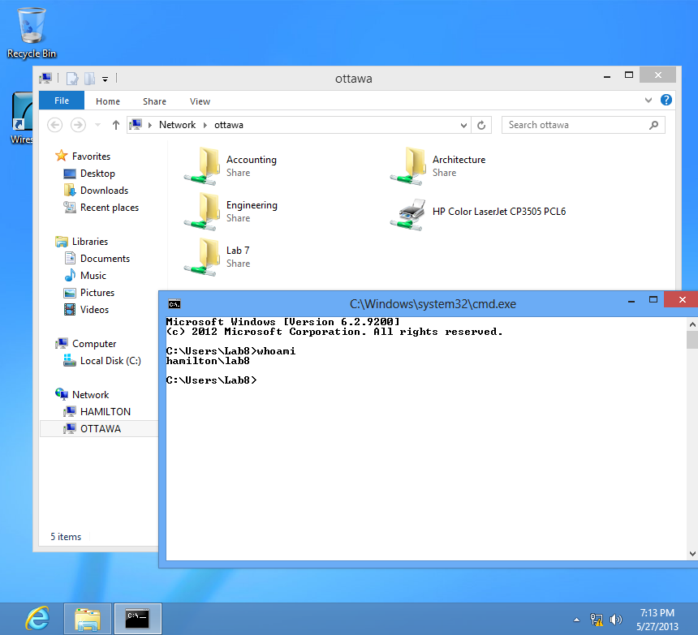

Fig. 9 Lab8 automatically accesses the shares on Ottawa

**13. Capture the whole screen on Hamilton. Your capture looks like figure 9**

[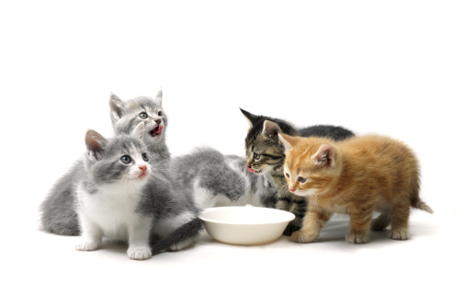](http://www.google.ca/url?sa=i&rct=j&q=&esrc=s&frm=1&source=images&cd=&cad=rja&docid=rtGg5n0o4cyT0M&tbnid=575Ywvlz4FWnWM:&ved=0CAUQjRw&url=http://cosmopolitan.sg/2013/01/18/for-the-love-of-my-sanity-stop-sharing-such-images-tan-lili/&ei=iPijUbvuDomjrQHR4YDQCQ&bvm=bv.47008514,d.aWc&psig=AFQjCNE_sF2Ao2E_MbilV192MuXZHrwvcw&ust=1369786808174609)

*Stop Sharing !!!*

*Go Home*